System Requirements :

***Functional requirements:***

The software shall allow patients to search for available appointment for a particular date and available medicine he can buy .

The software shall display a list of available doctors and doctor cv or profile, such as his certificates , his years of experience , the price of the appointment , and the availability of the doctor in certain time.

The software shall allow passengers to book a appointment for a selected doctor by entering their personal and payment information.

The software shall generate a confirmation number and a receipt for each booking and send them to the patient’s email address.

The software shall allow patients to cancel their bookings without any penalty within 24 hours of booking or before the check-in deadline, whichever is earlier.

The software shall allow registered users to check the status of their appointments and orders by entering their confirmation number or order ID.

The software shall notify registered users by email or SMS if there is any delay or change in their appointment status.

The software shall allow patients to create an online account by providing their name, email address, password, and security question and answer.

The software shall allow patients to log in to their accounts by entering their email address and password.

The software shall allow patients to view their booked appointments and orders and their details, such as order ID, arrival time if he wants it to be delivered , price, delivery details.

***Non-functional Requirements :***

The software shall have a user-friendly and responsive interface that adapts to different screen sizes and resolutions.

The software shall support multiple languages and currencies, depending on the user’s preference and location.

The software shall support multiple languages and currencies, depending on the user’s preference and location.

The software shall comply with the security and privacy standards and regulations of the E-Health care standards and the relevant authorities.

The software shall have a high availability and reliability, with minimal downtime and errors.

The software shall have a scalable and modular architecture, with the ability to handle increasing user traffic and add new features and functions.

***External Interface Requirements :***

***User Interface:***

The software shall have a graphical user interface (GUI) that consists of menus, buttons, icons, text boxes, drop-down lists, checkboxes, radio buttons, sliders, etc.

The software shall use a consistent and intuitive layout and design for the GUI elements, with appropriate colors, fonts, sizes, and alignments.

The software shall provide clear and concise labels, instructions, messages, and feedback for the GUI elements, with appropriate language and tone.

The software shall provide help and support features, such as tooltips, FAQs, tutorials, etc., for the users.

***Hardware Interface:***

The software shall run on both desktop and mobile devices, such as laptops, tablets, smartphones, etc. The software shall support the following operating systems: Windows, Mac OS, Linux, Android, iOS, etc.

The software shall support the following browsers: Chrome, Firefox, Safari, Edge, etc.

The software shall support the following input and output devices: keyboard, mouse, touch screen, microphone, speaker, camera, scanner, printer, etc.

***Software Interface:***

The software shall use a web-based or a cloud-based platform for the development, deployment, and maintenance of the software.

System use cases diagram

***Use Case 1: Describe Medicine***

Actor: Doctor

**Description:**

The doctor diagnoses and prescribes treatment to the patient.

**Main Flow:**

* The doctor logs into the system using their credentials.
* The doctor searches for the patient’s file using their name or medical number.
* The doctor enters the medicine name, duration of use, and other relevant details.
* The doctor sends the prescription.
* The system saves the prescription and automatically sends it to the pharmacy, where a pharmacist handles the dispensing.

---

***Use Case 2: Provide Lab Result***

Actor: Doctor

**Description:**

The doctor examines lab results and provides a diagnosis based on them.

**Main Flow:**

* The system notifies the doctor that the results are ready for review.
* The doctor reviews and analyzes the results through the system to update the diagnosis of the patient’s condition.

***Use Case 3: Update Medical Record***

Actors: Doctor, Nurse, Consultant

**Description:**

The actors update a patient’s medical record with new information about their condition, treatment, or progress.

**Main Flow:**

* The actor logs into the medical record system.
* The actor searches for and selects the patient’s medical record.
* The actor updates the record with new data, such as diagnoses, medication, treatment plans, or progress notes.
* The system saves the updated information and maintains an audit trail.

**Preconditions:**

- The actor has valid login credentials.

- The patient’s medical record exists in the system.

**Postconditions:**

- The medical record is updated securely and accurately.

***Use Case 4: Review Patient Data***

Actor: Doctor

**Description:**

The doctor gains insights into patient recovery statistics and common diseases to take necessary measures.

* **Main Flow:**
* The doctor accesses the system’s analytics module.
* The system displays statistics on cured patients and prevalent diseases.
* The doctor reviews the data to make informed decisions.

---

***Use Case 5: Dispense Medication***

Actor: Pharmacist

**Description:**

The pharmacist dispenses medications based on the doctor’s prescription and ensures safe usage.

**Main Flow:**

1. The pharmacist logs into the system using their credentials.

2. The pharmacist searches for the prescription using the patient’s medical number or prescription number.

3. The system displays details of the medication, dosage, and quantity.

4. The pharmacist reviews the prescription for accuracy and checks stock availability.

5. The pharmacist dispenses the medication and updates the system with dispensing details.

6. The pharmacist provides advice on dosage and precautions to the patient.

---

***Use Case 6: Patient Registration***

Actor: Patient

**Description:**

The patient creates an account to use the healthcare system.

**Main Flow:**

1. The patient opens the registration page.

2. The patient enters personal information.

3. The system validates the details and creates an account.

4. The system sends a confirmation email to the patient.

**Preconditions:**

- The patient does not have an existing account.

**Postconditions:**

- The account is created successfully.

---

***Use Case 7: Patient Login***

Actor: Patient

**Description:**

The patient logs into the system to manage appointments or personal information.

**Main Flow:**

1. The patient opens the login page.

2. The patient enters their credentials.

3. The system verifies the credentials and logs the patient in.

**Preconditions:**

- The patient has a registered account.

**Postconditions:**

- The patient is logged in.

---

***Use Case 8: Patient Request Emergency Help***

Actor: Patient

**Description:**

The patient requests urgent medical help through the system.

**Main Flow:**

* The patient selects the emergency option.
* The patient describes the emergency.
* The system sends an alert to emergency services.
* The system provides the patient with an estimated time of arrival.

**Preconditions:**

- The patient is logged in.

**Postconditions:**

- Emergency help is dispatched.

---

***Use Case 9: Book Appointment***

Actors: Patient, Receptionis

**Description:**

The patient or receptionist schedules an appointment.

**Main Flow:**

* The patient or receptionist logs into the system.
* The doctor’s schedule is reviewed.
* An available time slot is selected.
* The system confirms the appointment and sends a notification.

**Preconditions:**

- The patient is registered.

**Postconditions:**

- The appointment is scheduled successfully.

---

***Use Case 10: Cancel Appointment***

Actor: Patient

**Description:**

The patient cancels an existing appointment.

**Main Flow:**

* The patient logs into the system.
* The patient navigates to the scheduled appointments section.
* The patient selects an appointment to cancel.
* The system updates the appointment status to “canceled” and sends a confirmation.

**Preconditions:**

- The patient has a scheduled appointment.

**Postconditions:**

- The appointment is canceled successfully.

---

***Use Case 11: Health Monitoring***

Actors: Nurse, Consultant

**Description:**

The system monitors a patient’s health status through vital signs and data analysis.

**Main Flow:**

* The nurse logs into the system and accesses the patient’s record.
* Vital signs are collected and recorded.
* The system analyzes the data and notifies the consultant if needed.
* Observations and recommendations are documented.

**Preconditions:**

- The patient’s medical record exists in the system.

**Postconditions:**

- The patient’s condition is monitored, and data is securely stored.

---

***Use Case 12: Transport Patient***

Actor: Driver

**Description:**

The driver transports the patient to the desired location.

**Main Flow:**

1. The patient logs into the system and requests transport.

2. The system assigns a driver to the patient’s location.

3. The driver transports the patient to the destination.

---

***Use Case 13: Deliver Medicine***

Actor: Driver

**Description:**

The driver delivers medication to the patient.

**Main Flow:**

* The patient logs into the system and orders medicine.
* The driver picks up the medicine and delivers it to the patient’s location.

---

***Use Case 14: Update System Status***

Actor: Administrator

**Description:**

The administrator supervises the system and ensures smooth operation.

**Main Flow:**

1. The administrator logs in and reviews system status.

2. They manage doctor and nurse assignments, oversee salaries, and perform maintenance tasks.

---

***Use Case 15: Laboratory Results***

Actor: Laboratory

**Description:**

The technician performs tests and records results in the system.

**Main Flow:**

* The technician collects patient samples.
* Tests are performed, and results are uploaded to the system.
* The results are shared with the doctor for review.

Book Appointment

Choosing

Registration

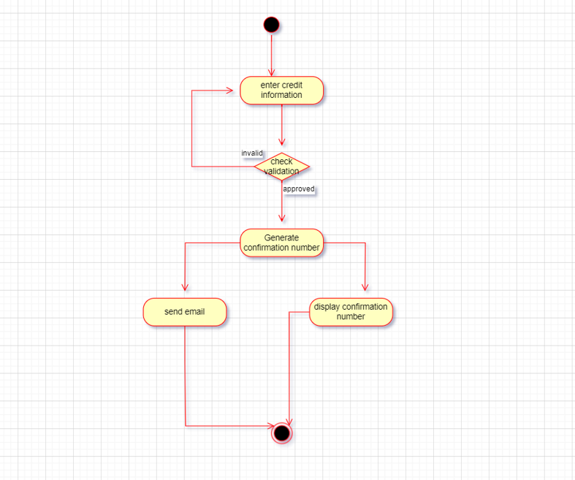Payment

